# Dropbox File Store Documentation

## Installation and Setup

### Dropbox File Store Installation / Setup

The EDD Dropbox File Store add-on installs to your WordPress site the same as any other WordPress plugin. Once installed to WordPress you will need to authorize the EDD Dropbox File Store app to access your Dropbox account on the Downloads -> Settings -> Extensions page on the admin side of your WordPress site. To start click the Get Code button.

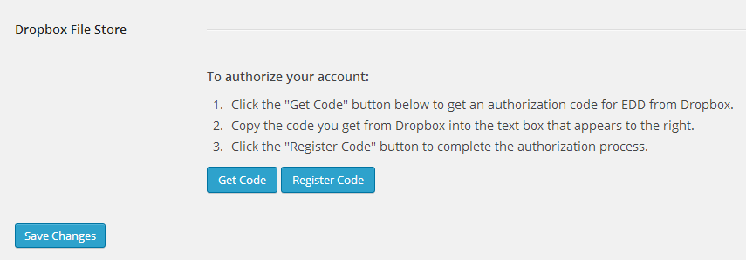

A new window / tab will open on a Dropbox page that will prompt you to authorize **Easy Digital Downloads – File Store** to access the files and folders in your Dropbox account.

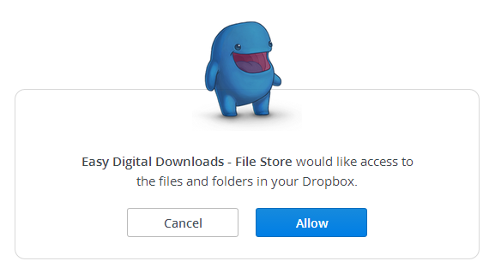

Click Allow and you will be provided with a code. Copy that code.

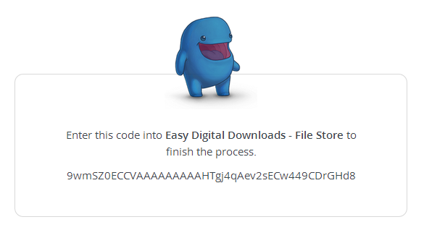

Back on your WordPress site copy the code into the text box that now appears to the right of the Register Code button and click the Register Code button.

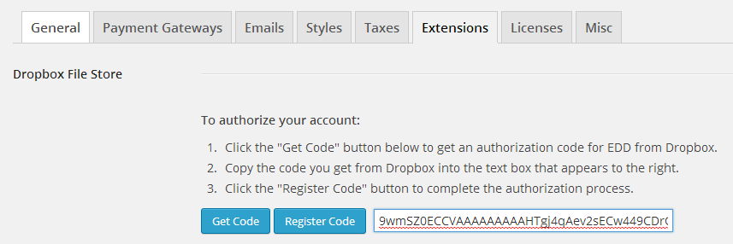

If you would ever like to de-authorize the EDD Dropbox File Store plugin or need to re-authorize you can do so from the same page by clicking the Remove Authorize button that will appear once you have completed the authorization process.

## Forcing File Downloads

By default Dropbox File Store will allow the browser to open supported files (such as audio or video files, PDF documents and straight text files) from within the browser itself. If you would prefer to have your buyers download the file and then open it from their device then you can check the **Force Download of Files** setting. This will add a parameter to the download URL that will force the browser to download and save the file rather than opening it.



## Using Files in Your Dropbox Folder

Once you have completed the setup steps above, setting up EDD to use a file in Dropbox is fairly simple. Go to the page of the Download you want to share and click the Upload a File link like normal. You will now see two new options on the Upload Media pop-up: **Upload to Dropbox** and **Dropbox Library.**

### Dropbox Library

The Dropbox Library allows you to use a file that you already saved to your Dropbox folder outside of WordPress. Clicking on the **Dropbox Library** option on the left of the pop-up will display the contents of your Dropbox folder starting at the root folder level.

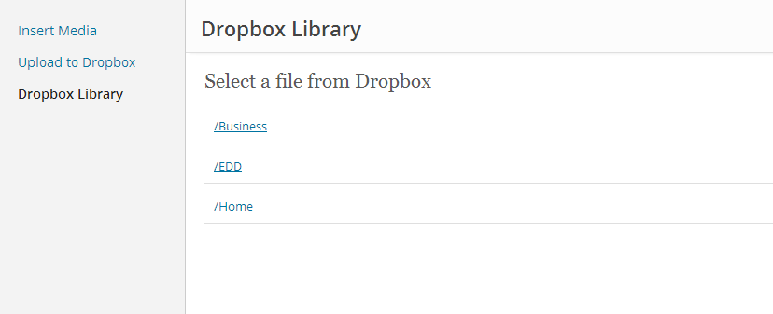

Navigate through your folders to find the file you want to use and click the **Select** button to the left of the file name.

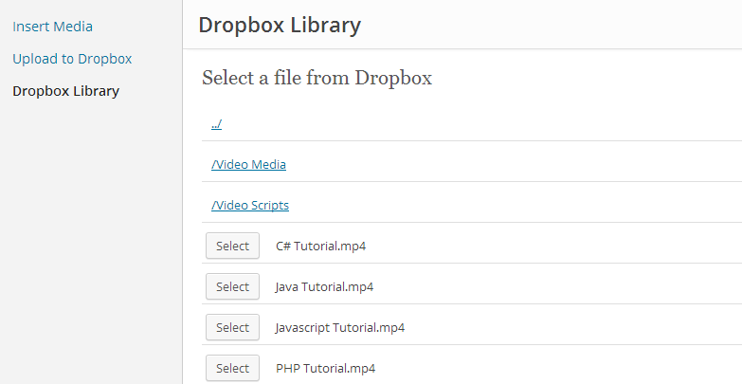

### Upload to Dropbox

The second option available in the Dropbox File Store add-on is to upload a file from WordPress to your Dropbox account and then use that file. This option bypasses the need to put your files in your Dropbox folder outside of WordPress.

To upload a file through WordPress, click on the **Upload to Dropbox**option on the Upload Media pop-up in WordPress. This will display the folder structure of your Dropbox folder along with a button to select the file you want to upload.

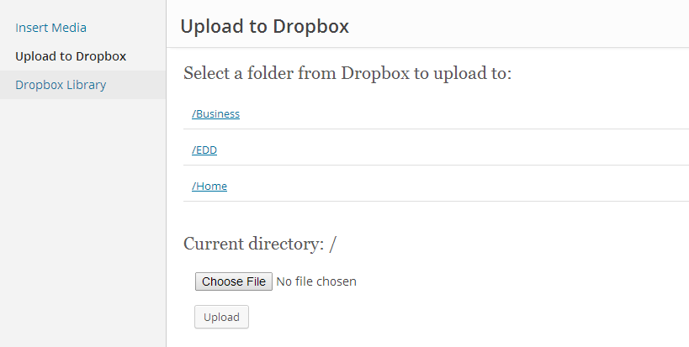

Navigate to the folder you want the file saved to and click the **Choose File** button to select the file on your computer. Once you have selected the file click **Upload** and wait while your file is uploaded to your Dropbox folder. Once it is completed the pop-up will display a success message and a new **Use File** button.

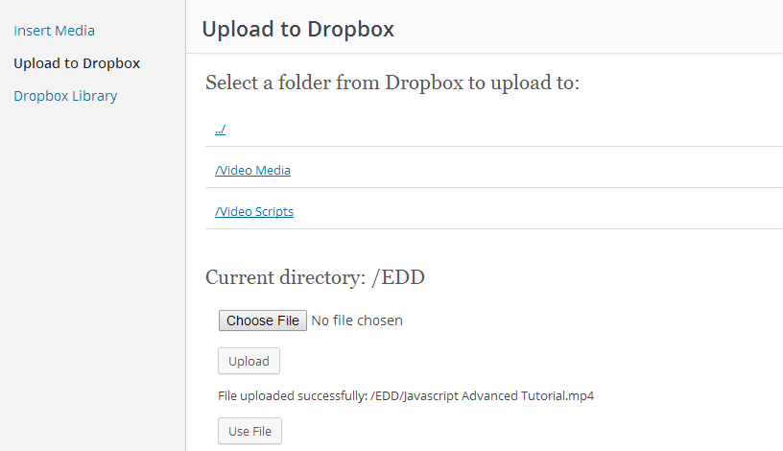

Click **Use File** to select the file you just uploaded as the file to use on your download.

*Please note: If there is already a file located in the folder you selected with the same name as the file you are uploading then the new file will have a number appended to it to make the filename unique. This will take the form of* filename (1).ext. *If you don’t wish to share the file with this name then you will need to first remove the duplicate or upload it to a different folder.*

### Using Your File

With either option, once the **Upload Media** pop-up closes the details for your file will be saved as a file on your download. Click **Update** when you are done with your changes and your users will now download this file from your Dropbox folder.

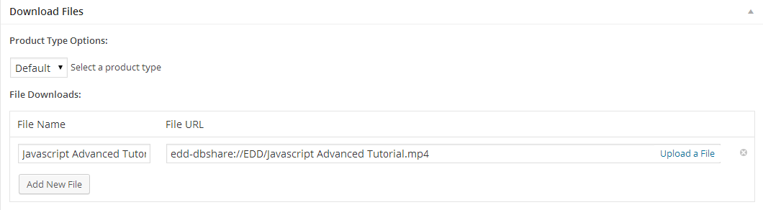

## Downloading Dropbox Files

The link provided to users to download their file from will expire after a period of time defined by Dropbox, currently four (4) hours. This is to prevent users from being able to share the download link with others with the intent to download the file without purchasing the download from your site first.

## Troubleshooting

### 64-Bit Requirements

The Dropbox API requires a 64-bit version of PHP running on a 64-bit server. While this requirement has been relaxed in Dropbox File Store so that you may still use the add-on on a 32-bit machine, please be aware that you will receive errors if you attempt to use larger files (over 2 GB in size) if you your site is not running on a 64-bit install. In addition, because of a Windows limitation, if your site is running on a Windows server you will not be able to support file sizes over 2GB even with a 64-bit install.

### Maximum Upload Size

WordPress and your website will have a maximum upload size, typically between 2MB and 8MB. If your files are larger than this then you will either need to change your site’s setting that controls this (typically in the php.ini file) or use the **Dropbox Library** option to configure your download.

### Image Upload Errors

There are also issues with uploading images to WordPress, in part due to file size constraints. Please see [Troubleshooting Images](http://en.support.wordpress.com/images/troubleshooting-images/) on the WordPress Support site for further details. Saving files to your Dropbox folder outside of WordPress and using the **Dropbox Library** option gets around all of this.

### Registration Code Expiration

The code provided by Dropbox during the authorization process expires after a short period of time and is only good for one authorization. If you receive an error when registering the code you may want to try again with a new code before any further troubleshooting steps.